Junit has the above limitation, in junit - feature files run in parallel and not scenarios.

Second problem is cross browser testing. We may have to maintain different packages for testing same feature on different browsers.

# Add the compiler plugin to achieve maven lifecycle commands-

# Third is maven fail safe plugin-

We can write any value for the goal field as per our convenience.

Jumbo plugin which needs to be added-

Open cmd and go to the project location. use the below code and hit enter.



Build success-

Open report-

For failed case we get screenshot-

Pdf report-

Index file also fine-

# Lets see the run with thread –

Run using mvn verify-

Don’t use mvn clean install.

Refresh project.

We get new folder here.

Open index.html.

We get such type of output.

Mine is not coming properly, for Naveen it works.

See naveens output-

# Lets increase one more feature file and see if thread count increases-

Output-

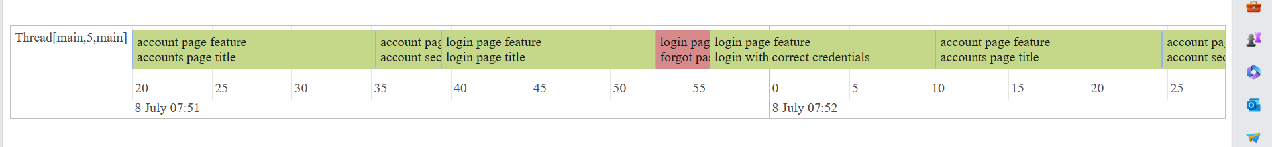

Cucumber report-

# Project structure-

# Codes from this chapter-

|  |
| --- |
| Runner file-  package com.myTestRunner;  import org.junit.runner.RunWith;  import io.cucumber.junit.Cucumber;  import io.cucumber.junit.CucumberOptions;  @RunWith(Cucumber.class)  @CucumberOptions(  features = { "src/test/resources/appFeatures/" },  glue = { "stepDefinitions", "appHooks" },  //this adapter needed for the new extent reports.  //we can generate timeline html reports for threads using timeline plugin. we can know how many threads participated.  //we can see what threads present in a pool, which threads executed which scenario.  //we can give name for timeline .. this is the folder which will be created once test runs.  plugin = { "pretty",  "com.aventstack.extentreports.cucumber.adapter.ExtentCucumberAdapter:",  "timeline:test-output-thread/"}    )  public class MyTestRunner {  } |